[**Памятка для родителей первоклассников**](http://schoolkr8.ru/blog/pervoklass/view/pamatka-dla-roditelej-pervoklassnikov)

[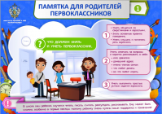](http://schoolkr8.ru/uploads/posts/images/2019-07/-B7ufT4OOqbH2Df6kv_V.png)[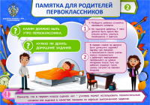](http://schoolkr8.ru/uploads/posts/images/2019-07/FJVCP8f2X_qtTxTtD_Ez.png)[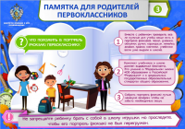](http://schoolkr8.ru/uploads/posts/images/2019-07/73S5ByxSNEkhrJxaUsHF.png)[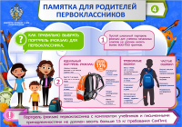](http://schoolkr8.ru/uploads/posts/images/2019-07/EF53dp1NH65zweOCIs9N.png)[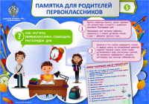](http://schoolkr8.ru/uploads/posts/images/2019-07/bDMDogwWjrF7ZilOszjh.png)[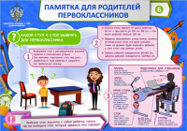](http://schoolkr8.ru/uploads/posts/images/2019-07/88JAd9qMi2ZIkjRU2F84.png)[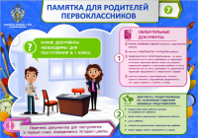](http://schoolkr8.ru/uploads/posts/images/2019-07/w3RIMm9EEQKauoPPUgTh.png)[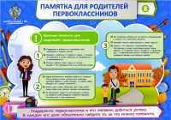](http://schoolkr8.ru/uploads/posts/images/2019-07/K0wIuGo-bnEr_go-zhFR.png)

[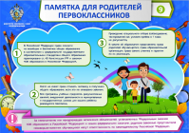](http://schoolkr8.ru/uploads/posts/images/2019-07/JRmWyWM9X46H1A0SomHW.png)[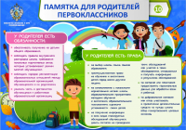](http://schoolkr8.ru/uploads/posts/images/2019-07/xd8vwChk2r5WzZIEnK_k.png)